SECR1213 NETWORK COMMUNICATION SEM1_2425
GROUP PROJECT

Introduction
This project is a group project with individual review. Its objective is to bring forth what you have learned in class into how it is in the real world. You will be tasked of building a small network with all its appropriate components, namely:
- Understanding user/customer needs and planning them around the budget given
- Planning and designing a network infrastructure for current and future needs
- Research and application of network devices availability, usability, cost and services
- Calculating and applying network IP addressing
- Reporting your work to customer
You will be given tasks that needed to be completed within the given time.
It is very important that you read this document carefully and follow the due dates and deliverables to get good marks. Ask if you don’t
understand something, and don’t wait until the last minute to do so.

THE TASKS

TASK 1: PROJECT SETUP [10 Marks]
In this task, you are to create your own team. Choose people who can contribute and work well and hard. A good team can mean a better quality of work and, as a result, a better grade.
- Create a group of 4 students per group and come up with a group name.
- Read the case study thoroughly. Make sure you understand it. Ask if you don’t.
- Create your own additional building layout and design based on requirements. Draw a floor plan (with actual scale). You MUST use any software to draw, just make sure that the result is clear and readable.

Deliverables:
  - Group name and members
  - Suggested floor plan.
  - Meeting minutes (all meeting minutes MUST be informational and specific).

Due date: To be notified later.
  - **Tips: Be logical and mature about this. Think of yourselves as Network Consultants and this is a contract.

TASK 2: INITIAL DESIGN - PRELIMINARY ANALYSIS [10 Marks]
In this task, you are to do a preliminary analysis, especially on current and future requirements and devices to be used. In real life, this portion is usually done through meetings and interviews. Once you find this information, you can determine whether the project is feasible.
- Generate a list of minimum 15 questions (it could be more) to ask the user or to research (the Internet, white papers, journals, etc.) with regards to the requirements and other information that is necessary to develop a network plan based on the case study.
- Find the answers for those questions by researching it.
- Determine the feasibility of the project, explain your reasons.

Deliverables:
  - List all of the questions and their answers (minimum 15 questions).
  - Explain the feasibility answer and reasoning.Meeting minutes (all meeting minutes MUST be informational and specific)..

Due: To be notified later.
  - **Note: If you find, through your research and interviews that your initial floor plan needs to be updated. You can do so and re-submit the plan.
  - **Tips: read case study carefully, brainstorm in group about all the questions you have. You will find that some of these questions you know the answer to already, some you need to research.
  - **Tips: Do include extra questions on what is needed per lab.

TASK 3: CHOOSING THE APPROPRIATE LAN DEVICES [10 Marks]
Now that you have a good idea of what you need to do (from your design and research), you need to realize it. You need to find out what devices (network and end-user devices) that you will need to achieve the objective of fulfilling the requirements and needs of the organization. There are many different types of network devices like routers, switches, patch panels, wireless devices, and cables – to name a few. These come in different brands too like Cisco, Huawei and Asus – each with their own capabilities and price ranges. Devices also come in different ranges – for home, small LAN, larger corporations etc. Choose the best to fit an academic institution.
You will need to do A LOT of research and discussion within your group to grasp concepts and make decisions on which device to use and why.

- Research the different network devices that you will need to accomplish the objective.
- Decide which LAN devices you need to accomplish the needs as mentioned in the case study.
- Find information on the devices you have chosen.

Deliverables:
  - List of devices and the quantity needed.
  - Based on the information gathered, reflect on these questions and write a report.

    - Are you surprised by the prices? How were you surprised?
    - Have you ever considered cost as a factor for choosing networking devices?
    - What are the major differences between the same devices from different brands? For example, Cisco and Huawei Routers.
- Meeting minutes (all meeting minutes MUST be informational and specific).

Due: To be notified later.
- **Note: work within your budget. Decisions for budget increase will be upon the study done.
- **Tips: Exploration is the key here. Start with a basic search on Networking Devices for schools or universities and work from there. All members MUST work together to achieve a successful end.

TASK 4: MAKING THE CONNECTIONS – LAN and WAN [10 Marks]
In this task, you are putting all the infrastructure and devices into place. For example – where the switch is placed in the lab? How are these new rooms/networks connected to the main institution network? How much cabling do you need? How do you connect the different floors?
Once your group has chosen the internetworking devices you will need for your network, the devices must be interconnected. Your group needs to consider four physical areas when planning: work area, telecommunications room (distribution facility), backbone or vertical cabling, and distribution or horizontal cabling. The purpose of this discussion is for the groups to consider the physical connections that must take place for networking to be successful.
Figures 1 and 2 gives you a basic idea of cabling structure.
You will also need to find out about what type of media (twisted pair, fibre optic, wireless) you need and its capabilities. Not all media are created equal and each has its own capabilities and limitations. Figures 3 and 4 shows you some examples.

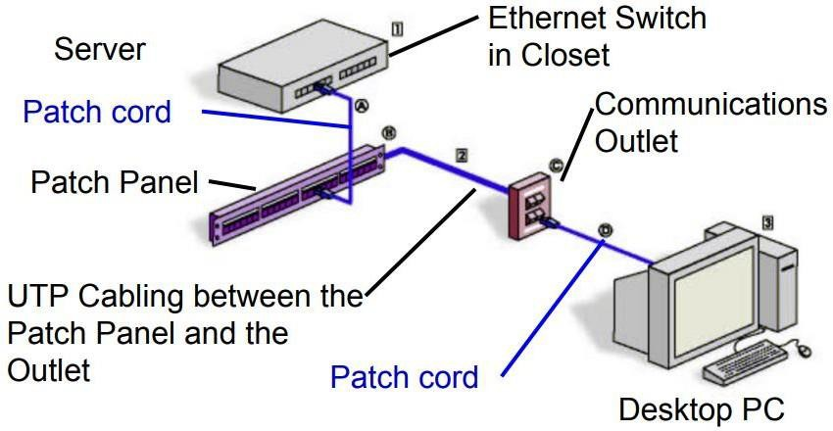

Figure 1: Example of Wired LAN cabling structure

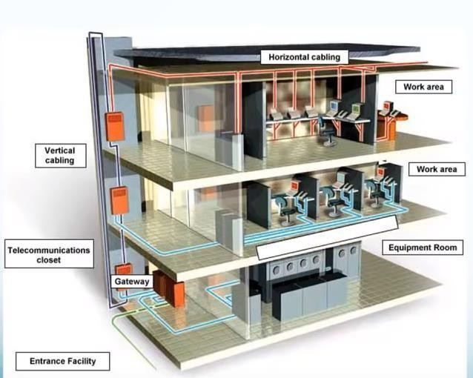
Figure 2: Another example of Wired LAN cabling structure

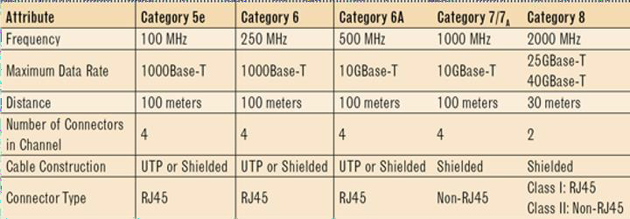
Figure 3: Different cable types

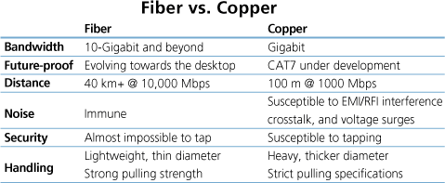
Figure 4: Difference between fiber and copper cable

- Identify the work areas on your floor plan.
- How many connections, patch cords and switch ports have you determined you need?
- Identify cable types and length.

Deliverables:
- Sketch/drawing of your PC & network devices arrangement. You can use any software available.
- The cable length in the identified work areas.
- Meeting minutes (all meeting minutes MUST be informational and specific).

Due: To be notified later.
  - **Note: Measure the floor plan for the case study to see the maximum distance they have to cover from the MDF (Main Distribution Facility). Do not forget to add in the cable length going up the walls and around corners. Record the lengths.
  - **Tips: scale is important here, to correctly suggest locations and cable structure. Cable lengths need to be determined and matched with technology used.

TASK 5: IP ADDRESSING SCHEME [10 Marks]
IP addressing is crucial in making sure that every host can connect to the network without conflict of addresses. In this task, you need to explore how best to divide the subnetwork from the Network Address assigned to your group.
- Get the Network Address for your group as stated in the document.
- Divide it in the best possible way for your network – all the different labs and rooms.

Deliverables:
- Complete and detailed workings of your subnetting and IP assignation to each lab and room.
- Meeting minutes (all meeting minutes MUST be informational and specific).

Due: To be notified later.
  - **Note: Look at your floor plan and the different rooms.
  - **Tips: IP addresses MUST be enough for all host as each host MUST have its own unique IP address

TASK 6: DOCUMENTATION AND REFLECTION [40 Marks]
Now that you have designed your building and network, assigned all IP addresses to hosts, it is time to report all your work, and reflect upon them. In this task there are 3 important things to complete: a group report, an individual report and an individual reflection video.
The objective of the report is to report the work done and reflect upon how it can be made better (now that you are more ‘in the know’). You will be given a guideline for the reports but you are advised to expand it to give a clearer view of your work, your suggestions and your reflections.
Report format include: Times New Roman 12 font, 1.5 spacing, numbering for each task, A4 size paper, printed double sided (save the trees!).

Task 6A: MAKING A GROUP REPORT
This report is a professional report to highlight your team, your results, your future suggestions and reflection of your work.
Table 1: Group Report Outline

Item | Description
Title page | Use this as title on cover “Network Design for Faculty of Computing Block N28B”. Add a by (your group name).
A Report Abstract | A summary of your report (1 page maximum)
Table of Contents | List the contents of your report here. This helps readers to know where exactly the content they are looking for is at.
Table of Figures | List all the figures (Figure number, figure title, page) for easy reference.
Introduction | A good introduction should tell the reader what the project is about in general terms. You should also outline the aims, scope and objectives of the project. You should also include assumptions on which the work is based on (if any).
Project background and an overview of the client’s current status and issue | This is your take on the background of the problem that you are trying to find a solution to. DO NOT copy-n-paste the case study here. This part is to give an initial understanding towards the content within your report.
A compiled solution of Task 1-5. | Here you put in all your results from the previous tasks. Include your reflection of the task as well. Your group should use the revised and corrected answers based on your group understanding.
Conclusion. | Describe your achievements, strengths and weaknesses. Give suggestions for project improvement.
*Anything else that would help a client’s decision-making process. | This is not compulsory, but it is a good reflection of your work.  For example: could the organization get a better quality of the outcome if they are willing to spend slightly bit more? Explain this then.
Team Members and responsibilities | Introduce team members and each of their responsibilities. Also refer to meeting minutes in appendix.

References: It is important that you give proper credit to all work that is not strictly your own, and that you do not violate copyright restrictions. | Include:  - All articles, books, journals etc. that you have referred in order to do and complete your work.  - References will follow the APA style (refer here for info: https://www.scribbr.com/category/apa- style/)
Appendices. | Include:  - The financial budget (what is bought, how much money is used and left, etc)  - All meeting minutes  - Pictures of your team working on the project  - Figures, tables and images (if need be)

Task 6b: MAKING AN INVIDUAL REPORT
This report is individual and unique. It MUST be your own individual point of view. It does not need to be submitted together with the group report, but you must submit it. You must describe your contributions in the project work, as well the contributions of others in your team. Be honest. This is where your integrity comes in.
The report is 2 pages long (maximum). The report must include the following:
    - Your group name.
    - Detail your contribution to the group and the project work
    - Detail the other members contribution to the group and the project work
    - Explain how you work as a group.
    - Explain what you have learned from working as a group.
    - Explain what you have learned from doing the project.
    - Your comments and suggestions on the project.

Task 6c: MAKING A 3-MINUTE VIDEO
This video is individual and must be a reflection of your work and experience throughout the project. This video must include the following:
    - Your intro (your name and group name).
    - A reflection on every task you did within the project. Reflection here means: what you learned (in subject matter and life experiences), how the project helps you with the subject matter.

Deliverables:
- Group project report:
- Softcopy (PDF) uploaded to e-learning.
- Individual report: uploaded PDF file to e-learning

- Video:
- Upload to YouTube and upload link to e-learning.
  - Due: To be notified later
  - **Tips: Plan, then write. That is the best way to write reports. It works for exam questions too.

FINAL THOUGHTS
Here are some advices for you to use during this project.
TASKS: It is easy to put things to the last minute when you have a few things to do at once. Time management is important here. If you push things to the last minute – your marks will reflect your work. Shoddy work = shoddy marks.
TEAMWORK: You work as a team. It does not mean that some do the work and others just coast and do nothing. Get you hand into everything, as this is how you learn. The project is designed to help you learn.
TEAMWORK: Sometimes it is hard when your team-mates do not want to work hard and you end up with a major chunk of the work. Write this in your individual report. Also, talk to your lecturer about this.
REPORT: It is easy to copy and paste existing work from the Internet. But that, especially without proper citation, is what is known as PLAGIARISM in the academic world. Plagiarism can result in you getting zero marks – or even a disciplinary action. It is best to stay away from plagiarism.
REPORT: With reports, you are reporting what you did. Do just that – so that the reader may understand everything that you did. And also understand the reason to why you did it that way. Problems arise when you did not do the work (the research, the reading, the calculating, the writing, etc.)
DELIVERABLES: E-learning records the time you submit your work. Lecturers can see if you were late in submission. Please remember that.
REFERENCES: References must be from reputable sources, that are reviewed. Blogs or personal web pages are not peer-reviewed, so it is not a reputable source.
AI HELP: Students are advised against using AI tools like ChatGPT to do your work for you. Turnitin submission is needed.

IMPORTANT NOTE: Submitting the work of others as your own is PLAGIARISM and ZERO MARKS will be awarded to the team that is involved.

CASE STUDY

Faculty of Computing Upgrade needs Background information
The Faculty of Computing (FC) currently has 1800 students (both undergraduate and postgraduate), 100 academic and 40 supporting staffs. They anticipate a 15% growth in both students and academic staffs in the next 4 years. To facilitate this growth, FC plans to build a new 2 –storey building. This new building will house 4 new labs, 1 video conferencing room, for virtual project meetings, and 1 hybrid classroom. It will also house a student lounge that will give students an area to work and relax while connected to the network via WIFI. A total 30 workstations for each lab. The labs are divided into: 2 general purpose labs, 1 Cisco Network lab and 1 Embedded lab (for purpose of IOT, Digital, sensors, etc). Each lab and the student lounge will be 14mx10m in size. Labs must be equipped with high-speed internet connection in preparation for education in line with 4IR (4th Industrial Revolution). The Cisco Network Lab is a teaching lab and must be equipped networking devices for teaching. Ask your faculty representative (i.e. your class lecturer) for more information.
The Embedded Lab must be equipped with devices and peripherals that can facilitate learning. The hybrid classroom must be setup for best performance and efficiency for teaching and learning. *Note: The lab size must be suitable for the workstations and other equipment needed for the lab, as well as comfortable for working/learning.
FC Dean wants the building to be ‘ready for anything’ and have a reliable, efficient and secure network that can be easily managed. He also noted that it should be cost effective.

Goals for the new system
As FC grows and moves forward into the future, so does the need for better equipment that will allow for this growth. All stakeholders want to prepare for future needs to the extent possible at the best value possible. It is important that during this transition from their old equipment to their new equipment, they do not stop providing access to their users.
FC also wants to take steps into the future with cutting-edge technology, but don’t want to be paying for it for the next 20 years.
FC needs to have an upgrade to their system that will allow them to utilize the elements they feel would help their business. Those elements are:
- A system that is easy to manage and scalable
- Improve overall performance.
- Provide protection from network breaches such as Internet Worms, denial-of-service attacks and e-business application attacks.
- Capability to support high-performance to the core backbone

Also consider such future issues as:
- A scalable network for future growth
- Wireless connectivity in the future.

IP ADDRESSING SCHEME

Each section will have 192.X.0.0/8 as their network address. Your instructor will assign which subnet address your team will have.

Group | Network Address
4.1 | 192.120.0.0/8
4.2 | 192.122.0.0/8
4.3 | 192.124.0.0/8
4.4 | 192.126.0.0/8
4.5 | 192.128.0.0/8
4.6 | 192.130.0.0/8
4.7 | 192.132.0.0/8
4.8 | 192.134.0.0/8
4.9 | 192.136.0.0/8
4.10 | 192.138.0.0/8
9.1 | 192.140.0.0/8
9.2 | 192.142.0.0/8
9.3 | 192.144.0.0/8
9.4 | 192.146.0.0/8
9.5 | 192.148.0.0/8
9.6 | 192.150.0.0/8
9.7 | 192.152.0.0/8
9.8 | 192.154.0.0/8
9.9 | 192.156.0.0/8
9.10 | 192.158.0.0/8
12.1 | 192.160.0.0/8
12.2 | 192.162.0.0/8
12.3 | 192.164.0.0/8
12.4 | 192.166.0.0/8
12.5 | 192.168.0.0/8
12.6 | 192.170.0.0/8

BUDGET

Each team budget is assigned by your instructor. If you find that you do not have enough budgets, you may write a request report to apply for more budgets with justification of needs.

Each Group Budget : RM5 million

MEETING MINUTE
Meeting minutes should follow this sample, filled with meaningful input. *Note: The red font is a suggestion.

MEETING MINUTES
DATE/TIME |  | 20 Oct 2024 10am
LOCATION
AGENDA |  | what is to be discussed
Meeting MC |  | who handled the meeting
ATTENDANCE
NAME |  | TIME | REASON FOR ABSENCE
AB |  | 1000
CD |  | 1010
EF |  | 1010
GH |  | 1045
MINUTES
NO. | ITEM DISCUSSED | IDEAS/SUGGESTIONS AND PERSON GIVING IT | PERSON IN CHARGE & DATE
1 | Find name | CD suggested ALB
2 | Software to use | EF - volunteered to find what’s out there | EF (23/10)
3 | Floor design | AB and GH  suggested….
4 | Next meeting | 23/10 - what should  be completed by then
5 | Meeting ended | 1200

DATE/TIME | 22/1/2025 – 1720H
LOCATION | Google Meet
AGENDA | i) Discuss about Task 4(mostly) and Task 5  ii) Decide who will to draw network diagram for each room  iii) Decide who will explain the structure for all rooms  iii) Divide task amongst the group members
Meeting MC | Muhammad Afiq Danial bin Rozaidie
ATTENDANCE
NAME |  | TIME | REASON FOR ABSENCE
Muhammad Afiq Danish bin Mohd Hazni |  | 1720H | -
Muhammad Syahmi Faris bin Rusli |  | 1720H | -
Muhammad Afiq Danial bin Rozaidie |  | 1720H | -
Dheshieghan A/L Saravana Moorthy |  | 1720H | -
MINUTES
NO. | ITEMS DISCUSSED | IDEAS/SUGGESTIONS AND PERSON GIVING IT | PERSON IN CHARGE & DATE
1 | Discuss the requirements of task 2 and task 3 | Every member discusses the requirement to complete Task 4 | Afiq Danish, Afiq Danial, Dhesh, Syahmi
2 | Discuss about who in charge for ground floor | Afiq Danish and Syahmi will in charge to explain and draw for each room on ground floor | Afiq Danish, Syahmi
3 | Discuss about who in charge for first floor | Afiq Danial and Dhesh will in charge to explain and draw for each room on first floor | Afiq Danial, Dhesh
4 | Time to finish Task 4 to proceed to Task 5 | Every member must finish before or on due that has been set | Afiq Danish, Afiq Danial, Dhesh, Syahmi  (Due 25/1/2025)

